**SL_Lookup** – gives ability select any record due to parameters. Store selected record id in {!v.recordId}. Also works without iconParam, soslParams, limitOfRecords. By default we can add seleceted record, writing its id in recordId attribute.

Contains next attributes:

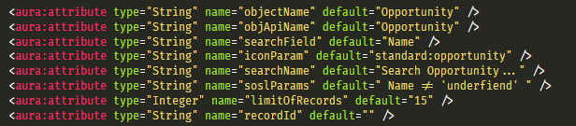

By default it looks like this

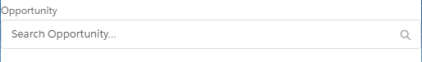

**SL_LookupMulti** – gives ability select several records due to parameters. Store all selected record id in {!v.recordId}. Also works without iconParam, soslParams, limitOfRecords. By default we can add seleceted records, writing their ids in recordId attribute, divided them by ;.

Contains next attributes:

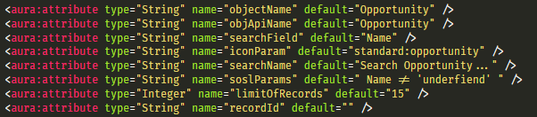

By default it looks like this

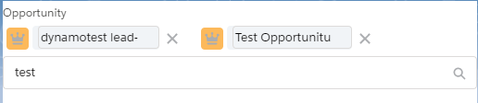

**SL_LookupPolimorph –** gives ability select record from different object types. Store selected record id in {!v.recordId}. Also works without iconParam, soslParams, limitOfRecords. By default we can add seleceted record, writing its id in recordId attribute.

Contains next attributes:

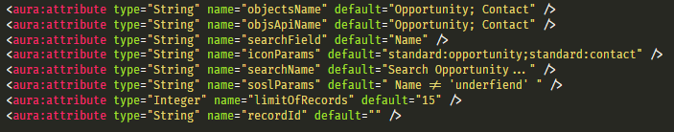

By default it looks like this

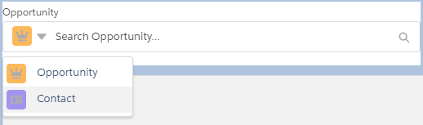

Additional component – SL_FocusBlurUtil – gives ability open and close drop down menus.

Apex class : SL_LookupController, SL_ LookupController_test